PADUA JOURNAL

Italian Artisans’ Revival After Economic Crisis Reflects Resilience of Small Industry
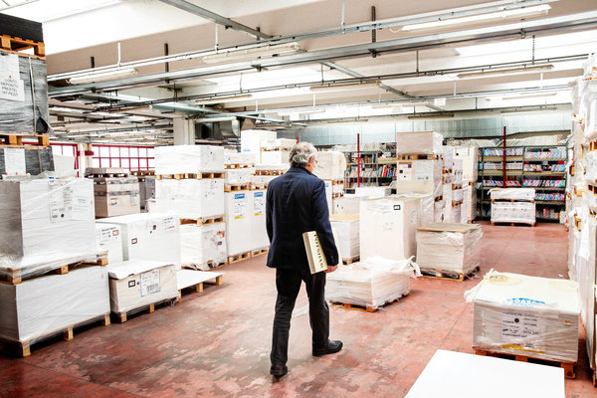
Editoriale Zanardi, a prestige book printer in northeast Italy, is one of the dozens of small and medium-size enterprises in Italy that were battered by the economic crisis.
MARCO GUALAZZINI FOR THE NEW YORK TIMES

By GAIA PIANIGIANI

APRIL 8, 2015
PADUA, Italy — High-end printing is an artisans’ job in Italy. For those books, the gluing and the binding of the pages is predominantly done by hand.
But at Editoriale Zanardi, a prestige book printer in northeast Italy, even the management fell into its workers’ hands last year, when they bought out the company that had employed them for years.
Zanardi is one of the dozens of small and medium-size enterprises in Italy that were brought to their knees by the economic crisis, but whose employees trusted in their companies enough to invest their unemployment and severance payments to create cooperatives and start producing again.
This kind of bonding together to weather Europe’s tough economic times has grown more common, not only in Italy but also in Spain and France, all countries that take pride in maintaining small, often family-run businesses.
But Zanardi’s story, equal parts tragedy and resilience, also in many ways reflects the character of Padua itself. Through its long history, it has been conquered and ruled by many, among them Huns, Byzantines, Lombards, Venetians and Austrians. But it has produced masterworks, like Giotto’s Scrovegni Chapel, and created one of Italy’s oldest universities, where Galileo once taught.
At the onset of Europe’s debt crisis, in 2008, Zanardi, which started in the 1960s as an artisanal rebinding shop in Padua, provided about 180 jobs. By 2012 that had shrunk to 105, after a series of bad management decisions and the effects of the downturn left the company accumulating debt.
Deeply distressed by the situation, one of the two owners committed suicide in the factory.
“I thought, I am not going to give up, and I poured all of my soul here,” said Solimano Dal Corso, the 42-year-old production manager of what is now the co-op.
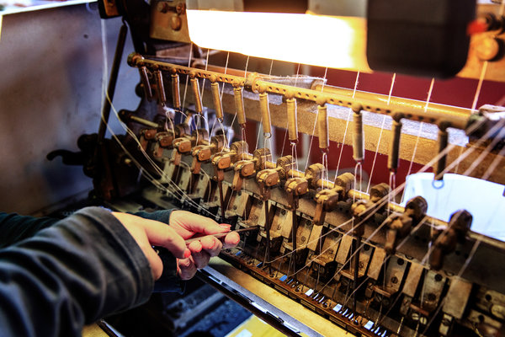
Serena Renier stitching a book at Zanardi.
MARCO GUALAZZINI FOR THE NEW YORK TIMES
“We became very flexible, took a pay cut, and became entrepreneurs,” he said. “We are giving up a little bit now, and investing in the future. This is how we do things here.”
The odds of such a turnabout remain long. Italian banks are extremely reluctant to provide cash to businesses, especially to those in trouble. International investors are not interested in small or medium-size enterprises, but rather in big brands of global reputation, experts said.
But in Italy, in particular, many workers nonetheless hold out faith that their specialized artisanal work can give them a unique niche, even in a globalized marketplace.
Mr. Dal Corso has worked in the printing business for his entire career, and when Zanardi went bankrupt, he found himself unemployed and worked for other, similar businesses in the area.
He wanted to figure out whether the co-op idea was feasible, and whether their possible competitors were way ahead of them.
“It turned out they were not,” he said, his hands on his hips as the printing machine rolled out fresh book pages on a recent crisp morning.
Last May, Mr. Dal Corso, 20 colleagues and the company’s former business consultant drafted a business plan and took it for evaluation to the Ministry for Economic Development in Rome. More than five months later, the new co-op was granted a license from the commercial court completing the bankruptcy procedure, and a lease on the machines and the facilities. The company was open for business again.
“Five months with no salary were bad, obviously, but five months of absence on the global market are very long,” said Mario Grillo, the business consultant who decided to invest in the co-op because he fell in love with the books that Zanardi produced.
“Every competitor wanted the brand and the clients,” he added. “None wanted the employees, but I always believed that these people were essential to produce these books.”
Zanardi used to have a global market share of about 30 percent of prestige and arts books. Over the years, the company invented the patented Octavius binding that allows tailor-made editions, such as the 20,000 copies of the collected James Bond books and the limited edition of “Goldfinger” — 300 books all covered in leather and real gold powder.
Zanardi also printed many Gallimard tour guides, children’s books and the memorial edition of the German newspaper Bild, a thick collection of front pages.
According to the Cecop-Cicopa Europe, the Europeanconfederation of industrial and service cooperatives, about 120 businesses became cooperatives in France in 2011 and 2012, and 75 in Spain in 2012.
“These enterprises cannot seek international investors,” said Valter Conca, professor of management and technology at the Milan-based Bocconi University. “They have to look elsewhere, and those who do make it are a drop in the sea, a rather limited phenomenon.”
Zanardi workers sought help from Coopfond, an institution that has funded over 40 such co-ops since 2008, and saved more than 1,200 jobs all over Italy. Coopfond provided economic resources and expertise to work through the transition.
“It is usually an uphill journey, as these companies often come from a bankruptcy or a very serious economic crisis,” said Aldo Soldi, general director of the fund.
Now the co-op aims to conquer a third of the previous market share, with a fourth of the social capital and the employees.
They have made partnership agreements with other local rebinding businesses to get help. They work in special shifts, with their schedules adjusting last minute to the company’s needs.
“This is Italy’s richness, its working culture that should be promoted and preserved,” Mr. Grillo said, watching his co-op colleagues working the machines. “When people are fully engaged, China is not a real competitor. Italianartisans can stillmake a difference.”

